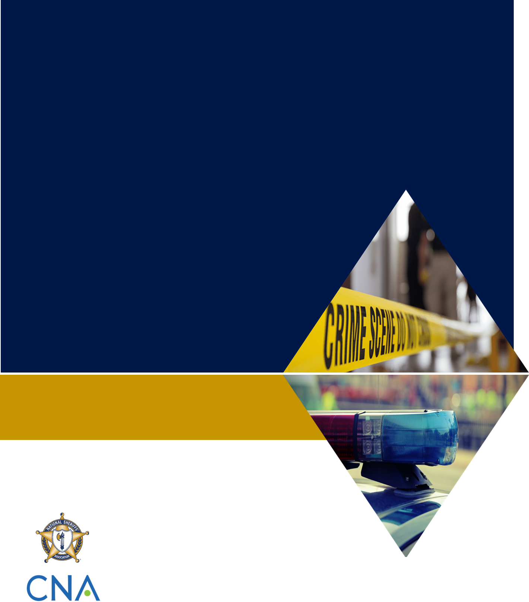
Table of Contents
Insert your jurisdiction logo here
[Insert Name of Military Installation]
Active Shooter Response Tabletop Exercise
Facilitator Guide

[Insert Date]
[Insert Classification]
Table of Contents i
Handling Instructions iii
Section 1: Exercise Overview 1
Background 1
Exercise Objectives 1
Exercise Structure 1
Scenario 2
Module 1: Scenario 3
Module 1: Discussion Questions 4
Operational Background 4
Module 2: Scenario 5
Module 2: Discussion Questions 6
Emergency Communications 6
Base Access and Incident/Unified Command 6
Tactical Operations 7
Module 3: Scenario 8
Module 3: Discussion Questions 9
Public Information and Family Reunification 9

Handling Instructions
- The title of this document is the [Insert Name of Military Installation] Active Shooter Response Tabletop Exercise: Facilitator Guide.
- Information gathered in this document is designated as [insert classification and handling instructions].
- For more information about the tabletop exercise (TTX), please consult the following point(s) of contact:
Name
Position
Agency/Organization
Contact information

Section 1: Exercise Overview

Background
Over the past 20 years, there have been more than 20 active shooter incidents on military installations. The most recent incidents, including the shootings at Pearl Harbor Naval Shipyard in Hawaii and Naval Air Station Pensacola in Florida in December 2019, have sparked conversation about the growing challenges involved in responding to active shooters on military installations. This TTX is designed to assist military and civilian law enforcement agencies assess their preparedness for such incidents. Through guided questions, exercise participants will discuss their roles and responsibilities, communication and coordination processes, and tactical operations in response to a fictional active shooter scenario inspired by real events. In addition to members of the law enforcement community, exercise participants may include state and local emergency managers, public health officials, emergency medical services (EMS) providers, public information officers, and representatives of community-based organizations involved in providing victim assistance.

Exercise Objectives
Listed below are examples of exercise objectives. Add, remove, or modify objectives as needed to meet the needs of your jurisdiction.
- Provide a forum for agencies to communicate and collaborate on planning and response preparations for an active shooter incident on a military installation.
- Confirm the roles, responsibilities, lines of authority, and operations coordination of civilian law enforcement and military personnel during an active shooter incident on a military installation.
- Confirm proper channels for information sharing among civilian law enforcement and military personnel during an active shooter incident on a military installation.
- Confirm the process for coordinating public information and family reunification following an active shooter incident on a military installation.
- Identify any gaps in planning, policy, or response coordination that would hinder response efforts.

Exercise Structure
The discussion will be divided into three modules:
- Module 1: Planning
- Module 2: Immediate Incident Response
- Module 3: Post-Incident Response
At the start of each module, the facilitator will present key scenario events to provide a backdrop for the discussion. The facilitator will then pose discussion questions to assist guide participants’ discussion. These questions are not meant to constitute a definitive list of issues, nor is there a requirement to address every question. Working with jurisdictional leadership, facilitators should choose not only what additional issues to address, but also what follow-up questions they would like to bring to the group in order to prompt discussion. Questions should be appropriate for the position and expertise of the people in the room, and should conform to the time constraints you have for your exercise.

Scenario
The active shooter incident takes place at [insert name of military installation]. The scenario includes civilian and military agencies, including [insert names of relevant agencies]. Please note that the events described in the scenario are fictional and intended only for the purpose of participating in the exercise. The scenario does not take place under pandemic conditions. Further scenario details are provided in each of the following three modules.

Module 1: Scenario
This Saturday afternoon, [insert name of military installation] will host its annual community festival, which features military equipment on display, children’s games, bounce houses, and food and beverage concessions for military personnel, their families, and the general public.
On Saturday morning, [insert name of military installation law enforcement agency] and the [insert name of local law enforcement agency] will activate and deploy resources in support of the event. The [insert name of military installation law enforcement agency] will lead security efforts, supported by officers from the [insert name of local law enforcement agency]. [Insert name of military installation law enforcement agency] and [insert name of local law enforcement agency] members will be posted at the entrance of the event and throughout the grounds. Operations command will be located near the entrance of the event.

Module 1: Discussion Questions
Key questions are numbered (1, 2, 3) and are in bold type. Follow-up questions that you can use to spark and guide the discussion are lettered (a, b, c).

Operational Background
- What formal or informal agreements (e.g., memorandums of understanding or memorandums of agreement)/relationships do you have with the military installation within your jurisdiction?
  - What local/state civilian law enforcement agencies could potentially be involved in the response?
  - Do you have a formal agreement regarding joint jurisdiction?
- How familiar are you with the facility (e.g., the layout, procedures for access)?
  - Do you visit/spend time on the installation? If so, how often?
  - Have you conducted joint training or exercises with the base in your jurisdiction? If so, what agencies/organizations participate?
- What is the level of collaboration between your organizations on a daily basis?
  - What is the level and nature of communication between your organizations on a daily basis?
- Have you dealt with incidents at the military base in your jurisdiction before?
  - If so, what were they? Are they included in training scenarios?
- Are you familiar with the base’s procedures regarding base access, foreign nationals, weapons, etc.?
  - Are most officers/deputies familiar with these procedures? Are they formally trained on or informed of them?

Module 2: Scenario
On Saturday at 1300 local time, the event begins and thousands of people enter the base. At 1400, while individuals are still entering [insert name of military installation], gunshots are heard throughout the base. A contractor armed with a handgun opens fire near the military equipment display area, wounding three adults before heading to the event entrance. As he continues to randomly open fire on the public, he injures two more individuals.
The surrounding crowd quickly disperses as people run to get away from the shooter. [Insert name of military installation law enforcement agency] quickly mobilizes and contacts the [insert name of local law enforcement agency] to send additional assistance.
At 1407, two deputies from the [insert name of local law enforcement agency] assigned to the event encounter the assailant. The man fires at both officers, wounding one. After a brief engagement, the officer fires at the assailant, killing him on the scene.

Module 2: Discussion Questions
Key questions are numbered (1, 2, 3) and are in bold type. Follow-up questions that you can use to spark and guide the discussion are lettered (a, b, c).

Emergency Communications
- How do 9-1-1 operations and dispatch work?
  - Does the installation have its own emergency call/dispatch center?
  - What are potential communications/interoperability challenges?
    - Language/vocabulary?
    - Are area radio systems interoperable? Is there a common channel that everyone could switch to?
    - Policies? Standards of procedure?
    - Training?
- How will your agency receive notification and gain situational awareness of the incident?
  - Who will be involved in notifying appropriate civilian agencies of the incident?
  - Upon receiving notification of the incident, what immediate key decisions/actions will your agency make?
- What reporting tools, if any, will the responding sheriff’s office use to communicate critical information to supporting agencies?
  - Common operational picture (COP) technology?
- What are the thresholds or triggers for requesting additional assistance from surrounding counties?
- Are there any policy gaps or functions that might impede or impact civilian agencies’ response efforts?
  - Must civilian agencies defer to installation agencies?

Base Access and Incident/Unified Command
- Are you familiar with the “lockdown” procedures on the base in your jurisdiction?
  - What are they? How do they differ from lockdown procedures in other major locations in your community, such as hospitals or schools?
- Do you anticipate that civilian responders will have issues accessing the base’s buildings?
  - Do lockdown procedures on the base take into account the arrival and presence of civilian responders?
  - Will evacuation procedures, if implemented, interfere with first responders coming onto base?
  - Are all first responders familiar with the base in your jurisdiction?
  - How might self-dispatched units affect access?
- What personnel will provide real-time directions/instructions for access?
- Will you establish a unified command?
  - If so, what agencies will be represented in the unified command?
  - Are those agencies trained and exercised in Incident Command Structure?

Tactical Operations
- How will the tactical police response be organized/managed?
  - Who will lead the response?
  - What agencies will be involved?
  - How might the lead change depending on the motivation of the shooter (e.g., terrorist incident, lone wolf, disgruntled employee)?
  - If you integrate personnel from multiple agencies, what issues do you anticipate regarding procedures/interoperable communications/tactical language?
- What are the active shooter protocols of the responding law enforcement agency?
  - Do they differ from those of the installation?
  - Do they potentially include response by plain-clothes officers? If so, how might military security identify those officers?
- Do you have joint police-EMS protocols?
- How will EMS operations be organized and managed?
- What challenges might have been encountered if the incident had occurred at another time of day or week (e.g., at nighttime or on a workday)?
  - Shift changes? Patrol schedules?

Module 3: Scenario
By 1420, civilian and military law enforcement have completely evacuated [insert name of military installation]. EMS personnel have arrived to assess the scene and treat the injured individuals.
According to reports, there are four injured individuals and two deaths—a civilian officer and a service member. Local EMS providers transport the victims to the nearest hospital for treatment.
Reports of the incident quickly circulate among social media sites as well as local and national news networks. Concerned family members begin contacting local and [insert name of military installation] authorities for answers regarding their loved ones.

Module 3: Discussion Questions
Key questions are numbered (1, 2, 3) and are in bold type. Follow-up questions that you can use to spark and guide the discussion are lettered (a, b, c).

Public Information and Family Reunification
Every incident is an opportunity to get the message right with clarity and speed. We are in the information environment every day and everything is on social media within seconds. Preparation will be critical for successful execution.
- What agency will be responsible for communicating with the public?
  - How will public information be coordinated among different agencies?
    - Who will be responsible for media monitoring, on-site management of media, and coordination of senior official briefings?
  - Will a joint information center (JIC) be established? If so, what agencies will send representatives to operate the JIC?
- What are the processes for coordinating victim assistance and family reunification services?
  - How will fatality management operations be organized and managed?
  - What agencies will lead or be involved in family reunification?

